Kashish Mittal

Northumbria University

**Depero, Fortunato (1892-1960)**

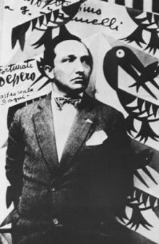

Fig. 1 Fortunato Depero

<https://it.wikipedia.org/wiki/Fortunato_Depero#/media/File:Fortunato_Depero.jpg>

Fortunato Depero was an artist, illustrator, and stage designer who played a central role in developing the art of modern typography. Affiliated with the Italian futurist movement, he was motivated by deep frustration with artistic traditions. He was perhaps the most persistent artist of futurism, with his work embodying many of the movement’s primary inclinations throughout his career. In typography, futurism broke the conventions of the printed page by using asymmetrical layouts, multiple colours and new typefaces. Depero pushed futurism beyond avant-garde circles and into the commercial sphere by applying typographic dynamism to advertising. His typographic expression was represented conceptually in his book *Depero Futurista* (1927), in advertising by his covers for *Vogue* magazine (1929-1930), and by an iconic poster entitled *Subway* (1929).

Depero was born on 1892, in Fondo, Italy. He was educated at the Scuola Reale Elisabettina in Rovereto, where he learned applied arts techniques and technical specialization. In 1910 Depero worked as an apprentice to a marble worker, which foreshadowed his subsequent experiments with architectural forms. He began his approach to futurism in 1913, when he discovered the futurist paper *Lacerba*. Depero’s career had begun as a fine artist, but overtime he became the most successful futurist graphic designer. Depero was received into the futurist movement in 1915 by Giacomo Balla, after exhibiting a series of drawings inspired by the sculptures of Umberto Boccioni. With Balla, he wrote a manifesto entitled *Futurist Reconstruction of the Universe* (1915), which proposed a utopian transformation of life into a total, multi-sensory work of art. His later publication *Depero Futurista* (1927) [Fig. 2] documented his experiments in this area. The book was known for being bound with metal bolts, an appropriation of the machine aesthetic already seen in futurist painting and architecture. With its unconventional binding, the book challenged the bibliophilic cult of the library - it would damage neighbouring volumes if placed on a library shelf.

After releasing *Depero Futurista*, he moved to New York, becoming the only Italian futurist to relocate to the USA. Herejected traditional rules of layout and used multi-coloured text in modern typefaces. Many of his designs consisted of black and white geometric shapes in a paper cutout style. The simplicity of his technique fulfilled the concept of the *Futurist Toy*, which held that an image should be stimulating to both adults and children. These designs were easy to reproduce by line block in newspapers and by colour lithography in posters.

Depero injected futurist design into advertising by working for publications such as *Vogue, Vanity Fair* and *The New Yorker.* A series of covers for *Vogue* from 1929 to 1930 are particularly significant [Fig. 3 and 4]. In his 1932 manifesto, *The Art of Advertising*, Depero stated, ‘The art of the future will be powerfully advertising art,’ and called for advertising to convey a new enthusiasm for ‘our glories, our men, our products.’ In 1929, Depero wrote the outline for *Il Futurismo E L’arte Pubblicitaria* (*Futurism and the Art of Advertising*), which argued that advertising would have a major impact upon art in the future, thus anticipating the pop art of the late 1950s and 1960s. Pursuing this idea, Depero invented the concept of architettura pubblicitaria (advertising architecture). Building on Marinetti’s experiments with typography, he used bold typographic forms to create architectural structures. In his Bestetti Treves Tumminelli Book Pavilion at the Monza Biennial (1927), words became architectonic elements and the building itself became a monumental advertisement [Fig. 5].

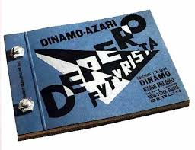

Figure 2: Depero Futurista <http://www.colophon.com/gallery/futurism/1.html>

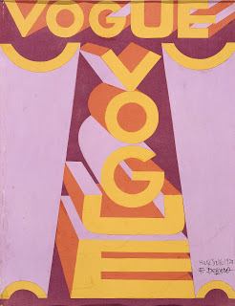

Figure 3: Fortunato Depero, *Vogue Magazine covers* 1929 and 1930. <http://designhistorymashup.blogspot.in/2008/04/fortunato-deperos-role-in-typographic.html>

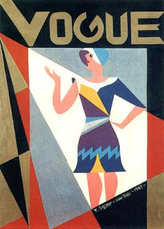

Figure 4: Fortunato Depero, *Vogue Magazine covers* 1929 and 1930. <http://designhistorymashup.blogspot.in/2008/04/fortunato-deperos-role-in-typographic.html>

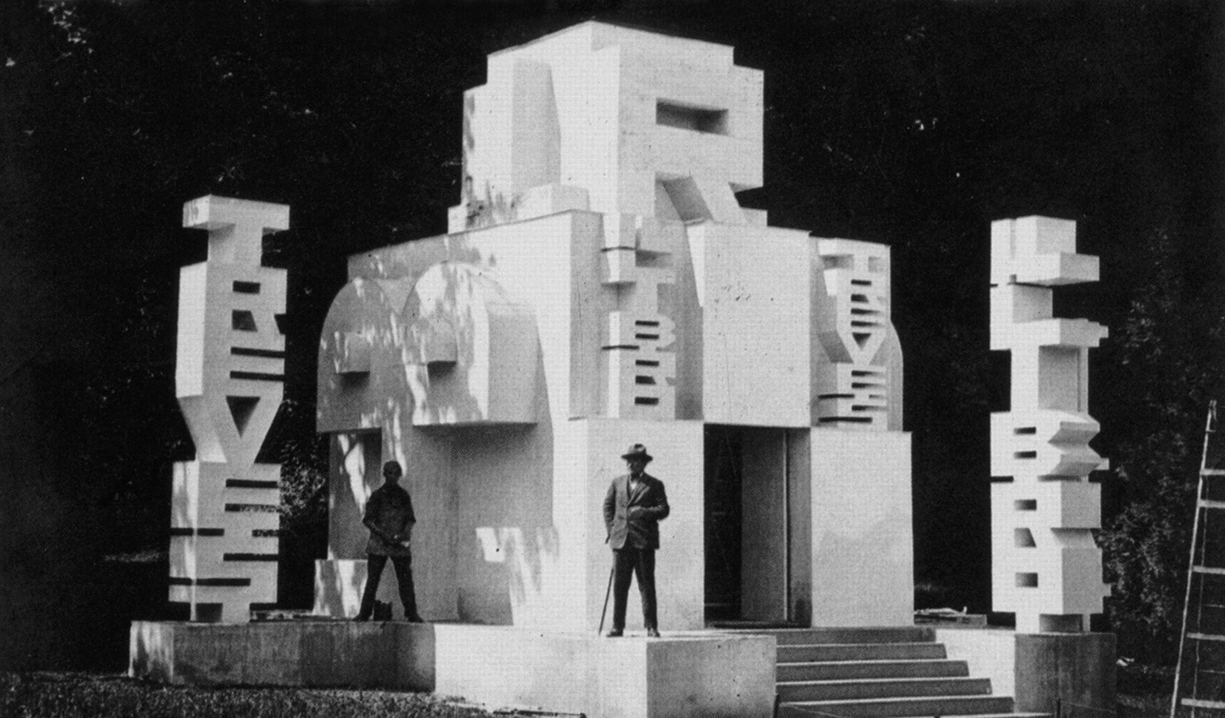

Figure 5: Depero in front of the Bestetti Treves Tumminelli Book Pavilion at the Monza Biennial (1927)

<http://jdh.oxfordjournals.org/content/21/4/335/F11.large.jpg>

Depero created a series of advertisements for the Italian aperitif Campari, including a wooden sculpture and a number of posters [Fig. 6]. These works were collected in a book entitled *Numero Unico Futurista Campari 1931*. Additionally, he designed a distinctive bottle for Campari Soda (1932), which is still in use today [Fig. 7].

Depero was also interested in painting. *Flora E Fauna Magica* (*Magical flora and fauna*) [Fig. 8] is one of the most bizarre, imaginative and surprising paintings made by Depero at the beginning of the 1920s. The dreamy atmosphere, the stylization of forms, and the distorted perspective all contribute to Depero being an avant-garde artist. In the centre of the painting is a blue elephant with two heads and three tails. The foreground has a series of fantastical flowers and shrubs, which on a closer look almost seem menacing. There is an exotic bird, a camel, and three flying fish with the fisherman with a dark complexion, in the middle who is fishing in a pool without water. The fisherman’s shadow is a strange purple and is missing the mustache and the fishing rod. Thus, Depero’s interest in antiquity permeated through several of his works and sometimes referred to many periods of art history.

Depero is an excellent example of an artist who continued to define himself as futuristic, while, in reality, incorporating many references to the past. His work thus becomes a complex set of elements and styles. Towards the end of his life, Depero constructed the *Galleria Permanente E Museo Depero* (1957) in Rovereto, Italy, a museum dedicated to preserving his work and that of other futurist artists. Today it contains over 3000 artworks and 7500 manuscripts pertaining to futurism.

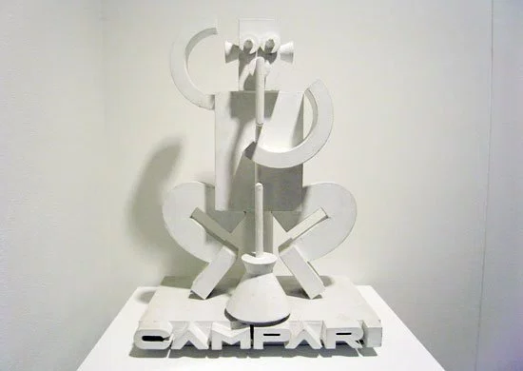

Figure 6: Fortunato Depero, Advertising wooden sculpture for Campari, 1926. <https://drehergraphicdesign.files.wordpress.com/2012/04/dep11.jpg>

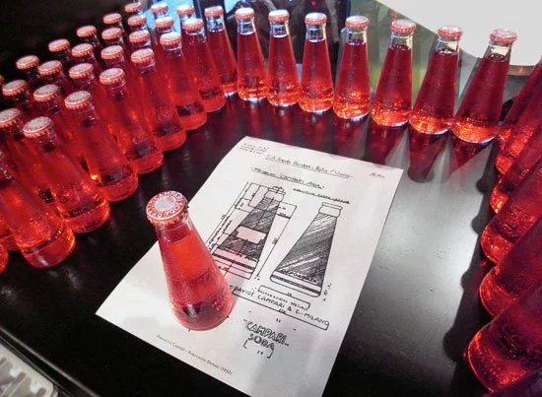

Figure 7: Fortunato Depero, Campari Soda bottles, 1932. <https://drehergraphicdesign.files.wordpress.com/2012/04/dep11.jpg>

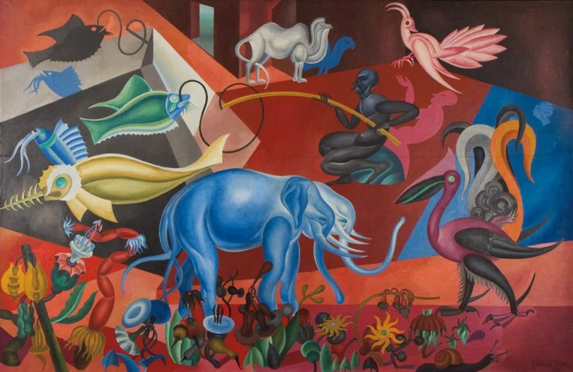

Figure 8: Fortunato Depero, *Flora E Fauna Magica*, Oil on canvas, Private collection, 1920. <http://www.italianmodernart.org/flora-e-fauna-magica-and-citta-meccanizzata-dalle-ombre-seeking-inspiration-in-the-past/depero_flora_e_fauna/>

**Further Reading:**

Chiesa, L. (2010) *Transnational Multimedia: Fortunato Depero’s Impressions of New York City*, University at Buffalo.

Cremoncini, R. (2000) *Fortunato Depero: Carnival of Colour*, Salford: Lowry Press.

# Depero, F., Scudiero, M. (2015) *Futurist Depero 1913-1950*, Fundación Juan March.

# Nason, G. (1998) *Depero Dal Futurismo Alla Casa (Italian Edition),* Edizioni Charta Srl.

Walter, A., Braun, E. (2014) *Italian Futurism, 1909-1944: Reconstructing the Universe*, Guggenheim Museum; First Edition.